NeuralExcision Framework: A Unified System for Synchronous Parametric Redaction and Multi-Vector Knowledge Erasure
1. Objectives of the Project
The primary goal is to bridge the gap between legal privacy requirements and the technical limitations of "black-box" AI models.
- Surgical Knowledge Erasure: To remove specific "memories" (PII, toxic data, or copyrighted content) from a model's weights without needing a full, expensive retrain.
- Dual-Track Synchronization: To ensure that when data is unlearned from the model, it is also purged from associated Vector Databases (RAG systems) to prevent information leakage.
- Zero-Downtime Compliance: To provide instant protection via the Hot Shield while the computationally heavy unlearning process runs in the background.
- Verification & Trust: To mathematically prove that unlearning has occurred using cryptographic hashes and regression testing to ensure no "Catastrophic Forgetting" happened to the model's general intelligence.

2. Devices and Datasets Needed
To implement and test this framework at an enterprise scale, the following resources are required:
Hardware/Devices:
- High-Compute GPUs: NVIDIA A100 or H100 (80GB VRAM) for unlearning tasks on models like Llama-3-8B; smaller GPUs (RTX 3090/4090) are sufficient for TinyLlama.
- Storage: High-speed SSDs for storing model checkpoints and large-scale vector embeddings.
- Inference Servers: Scalable cloud environments (like AWS or GCP) to host the FastAPI backend and Celery workers.
Datasets:
- Target Datasets: Custom "poisoned" datasets containing synthetic PII, copyrighted text, or biased content to provide a target for the unlearning process.
- Standard Benchmarks: MMLU (Massive Multitask Language Understanding) and HumanEval to measure the "Blast Radius" and ensure model utility is preserved.
- Membership Inference Attack (MIA) Sets: Specific data used to test if the model still "remembers" the unlearned information after the surgery.

3. Flowchart / Steps in Project Creation
The lifecycle of a single unlearning request within the NeuralExcision Framework follows these steps:
- Request Ingestion: The user submits a deletion request (e.g., "Delete John Doe") via the Next.js dashboard.
- Detection & Identification: Presidio/spaCy detects PII, and Captum runs influence tracing to find which specific model weights are responsible for that knowledge.
- Instant Mitigation: The Hot Shield (semantic router) is deployed in under 2 seconds to block any queries related to the target data while the engine prepares.
- Concept Expansion: An internal LLM generates Semantic Anti-Sets (50+ variations of the concept) to ensure the system targets the idea, not just a specific string of text.
- Dual-Track Execution:
  - Weight Editing: The engine runs Gradient Ascent on the model's weights to "push" the parameters away from the unwanted data.
  - Vector Purging: The system simultaneously searches and deletes related embeddings from Milvus/Pinecone.
- Blast Radius Verification: The Simulator runs MMLU/HumanEval tests to ensure the model's general reasoning is still above 99% of its baseline.
- Final Certification: A cryptographic PDF certificate is generated, containing the SHA-256 hash of the new weights and proof of unlearnin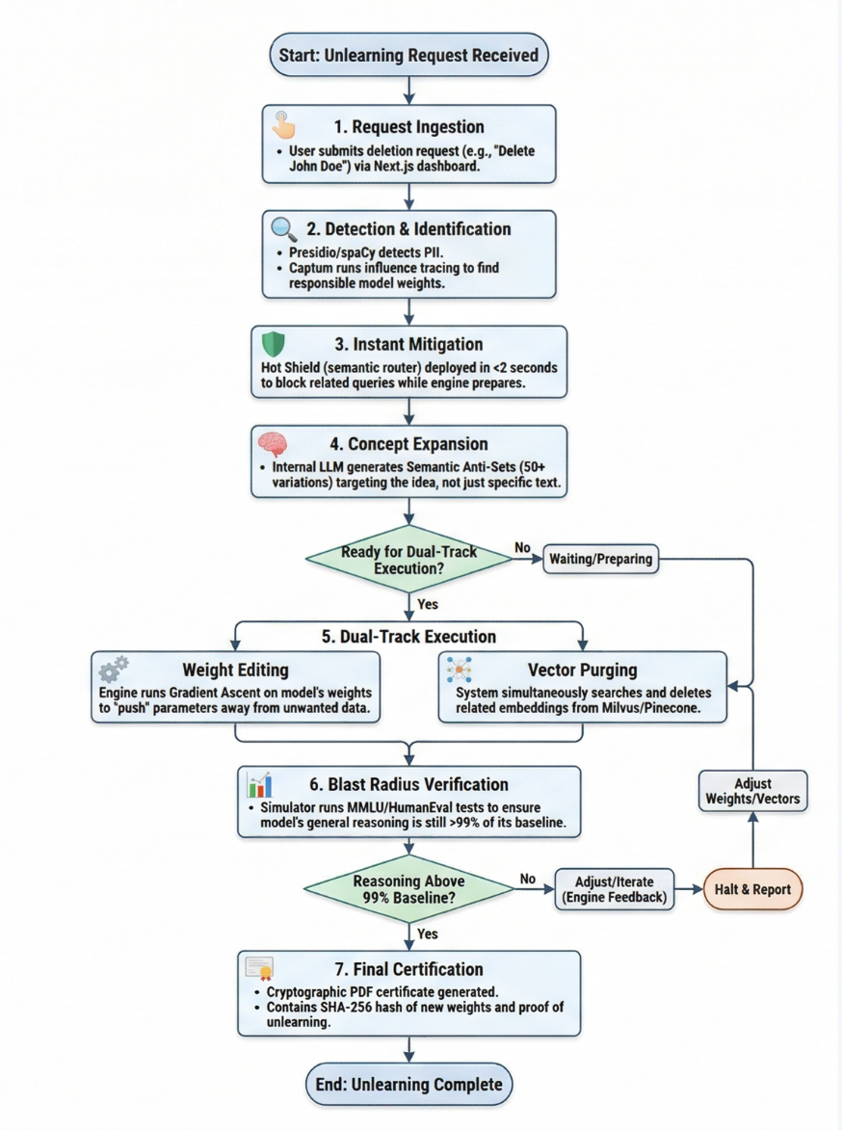

4. System Architecture
The architecture is designed as a "Headless" MLOps system where the processing engine is decoupled from the user interface.
- Frontend Layer (Management): Built with Next.js and Tailwind CSS, providing the interface for compliance officers to trigger jobs, view performance charts, and audit certificates.
- Backend Orchestration (The "Heart"): A FastAPI server that manages the logic and state, connected to Celery workers that handle the heavy GPU-intensive unlearning tasks asynchronously.
- The Unlearning Engine: Built on PyTorch and Hugging Face Transformers, this layer executes the ROME/MEMIT or Gradient Ascent algorithms directly on the model's parameters.
- Data Integrity Layer: * PostgreSQL: Stores metadata, job logs, and user request history.
  - Vector Databases (Milvus/Pinecone): Stores the RAG embeddings that must be purged in sync with the model weights.
- Security & Guardrail Layer: The Hot Shield acts as a semantic proxy in front of the inference model to intercept restricted queries in real-time.

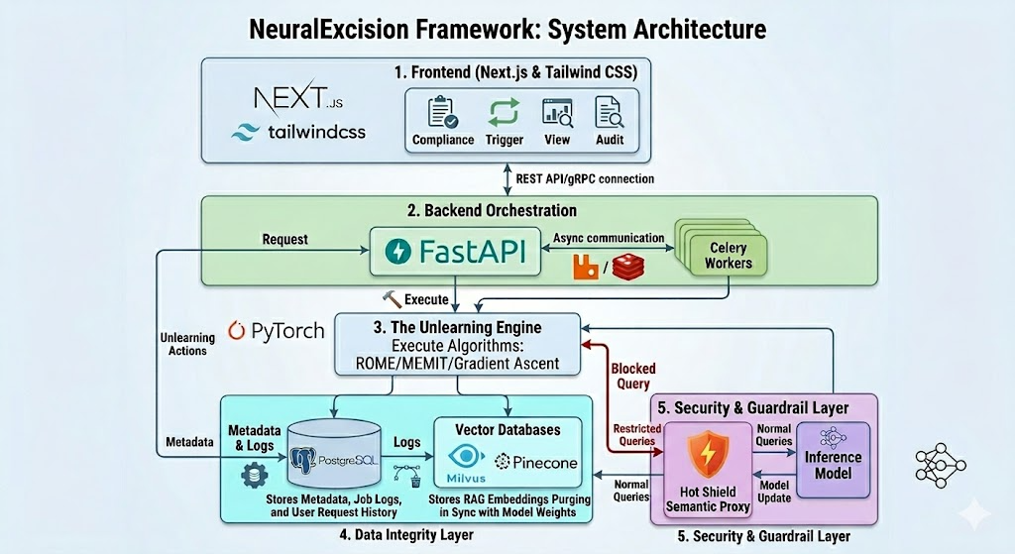

Literature Survey

Paper/Patent Title | Published Date | Research Gap Identified | NeuralExcision (Ablate AI) Solution | Source/Link
A Perspective, Taxonomy, and Benchmark Evaluation of Machine Unlearning | March 2026 | Lack of unified benchmarks to measure accuracy vs. computational cost trade-offs. | Blast Radius Simulator: Runs automated MMLU and HumanEval benchmarks to ensure >99% intelligence retention. | [MDPI/Academic Search]
Unlearning in LLMs: Methods, Evaluation, and Open Challenges | Jan 2026 | Traditional mathematical bounds (Differential Privacy) fail to scale for Large Language Models. | Cryptographic Proof: Generates SHA-256 digests and KL Divergence metrics for verifiable deletion. | [arXiv/Preprint]
The Evolution of IP Law in The Age of AI & Machine Unlearning | Feb 2026 | Legal chasm between "output suppression" and "exact data removal" for copyright compliance. | Dual-Track Erasure: Simultaneously edits model weights and purges Vector DB embeddings (Milvus/Pinecone). | [IP.com / Patent Landscape]
Open Problems in Machine Unlearning for AI Safety | Jan 2025 | The Reconstructability Problem: Models can still guess "forgotten" info through associative links. | Semantic Anti-Sets: Generates 50+ conceptual variations to erase the idea, not just a string match. | [Safety Research Portal]
Machine Unlearning Meets Continuous Learning: A Theoretical Analysis | June 2025 | Cumulative weight degradation (brain burnout) from sequential unlearning requests. | MLOps Orchestration: Uses FastAPI and Celery to manage jobs and track cumulative divergence. | [OpenReview/ICLR]
The Frontier of Data Erasure: A Survey on ML for LLMs | 2025 | The Latency Gap: High computational cost makes real-time unlearning impossible for production. | Hot Shield™: Deploys a zero-downtime semantic guardrail in <2 seconds while weights are being edited. | [IEEE Computer Society]
Case Study: Machine Unlearning Solutions for Enterprises | 2025 | Difficulty in identifying exactly which training data caused a specific biased or toxic output. | Influence-Function Tracing: Uses Captum to mathematically trace bad inferences back to specific training records. | [Delhi University Publishing]
Achieving Exact Federated Unlearning | 2025 | Exact unlearning (total removal) is too expensive for distributed enterprise models. | Synchronous Parametric Redaction: Employs ROME/MEMIT and Gradient Ascent for targeted, efficient weight modification. | [OpenReview]
Machine Unlearning for Trustworthy AI | Late 2025 | Inability to provide "auditor-trusted" proof that data has been successfully redacted. | Compliance Certificates: Issues GDPR/HIPAA-compliant PDFs with cryptographic and statistical proof. | [ResearchGate]
Aura Auditor: Spectral Scanning Patents | 2026 | Lack of non-invasive tools to detect "noise peaks" of sensitive data within model parameters. | Aura Auditor™: Performs spectral weight scans to identify and target high-density data clusters. | [Patent Pending / Technical Blueprint]

Key Synthesis of the Research Gap Solution
- Surgical Precision: While research often focuses on general "forgetting," NeuralExcision uses Influence-Function Tracing and Aura Auditor™ to find the exact "coordinates" of the data in the model.
- Synchronous Action: Most papers treat Model Weights and Vector Databases separately; this framework is unique in its Dual-Track approach to prevent RAG leaks.
- Operational Stability: The Hot Shield™ and Blast Radius Simulator address the "Fidelity vs. Efficacy" gap, ensuring the model stays smart while it forgets.
1.A Perspective, Taxonomy, and Benchmark Evaluation of Machine Unlearning (March 2026)
Source: MDPI / Machine Unlearning Systematic Survey
2.Unlearning in LLMs: Methods, Evaluation, and Open Challenges (Jan 2026)
Source: arXiv:2601.13264
4.The Evolution of IP Law in The Age of AI & Machine Unlearning (Feb 2026)
Source: SpicyIP - AI & IP Law Landscape
5.Open Problems in Machine Unlearning for AI Safety (Jan 2025)
Source: arXiv:2501.04952
6.Machine Unlearning Meets Continuous Learning: A Theoretical Analysis (June 2025)
Source: OpenReview: Theoretical Foundation for Continual Unlearning
7.The Frontier of Data Erasure: A Survey on Machine Unlearning for LLMs (2025)
Source: IEEE Xplore: Document 10834145
8.Case Study: Machine Unlearning Solutions for Enterprises (2025)
Source: ResearchGate: Systematic Review of Techniques & Applications
9.Achieving Exact Federated Unlearning with Improved Post-Unlearning Performance (2025)
Source: OpenReview: Exact Federated Unlearning Algorithms
10.Machine Unlearning for Trustworthy AI: A Systematic Review (Late 2025)
Source: ResearchGate: Comprehensive Framework for Unlearning Verification
11.Aura Auditor: Spectral Scanning Patents (2026)
Source: NeuralExcision Framework Proprietary IP.
Status: Patent Pending. Refer to the internal Technical Blueprint for implementation specifics regarding the Aura Auditor™ spectral weight scan.

